



**ITIDA egFWD**

**Udacity in collaboration with Sprints.ai**

**Embedded Systems Professional Nanodegree Program**

**Traffic Lights Project Overview**

Done By:

|  |  |  |
| --- | --- | --- |
| **Name** | **Phone** | **Email** |
| Hossam Eldin Mahmoud Atta | 01097666269 | [Hosseldinatta@gmail.com](mailto:Hosseldinatta@gmail.com) |

1. **System Description:**

This project simulates the process of modern traffic lights system. A modern traffic light system contains a traffic light for the cars, and one for the pedestrians. The project shows what should happen when a pedestrian tries to cross the road and their interaction with the system.

1. 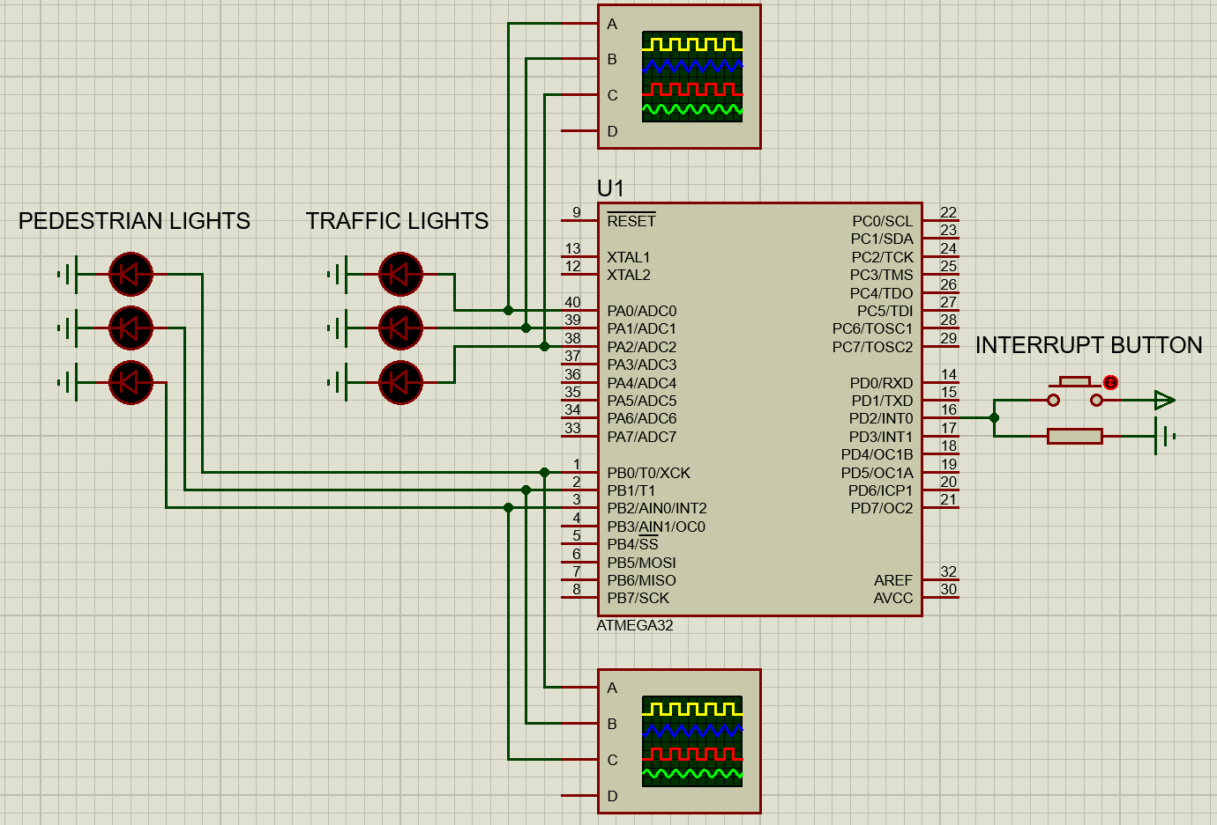**System Design:**

The system consists of the following components:

* ATMega32 Microcontroller
* Red, Yellow, Green LED Lights
* Electrical Resistors
* Buttons
* Electrical Power Source
* Electrical Ground Source

1. **System Flow Chart:**

* 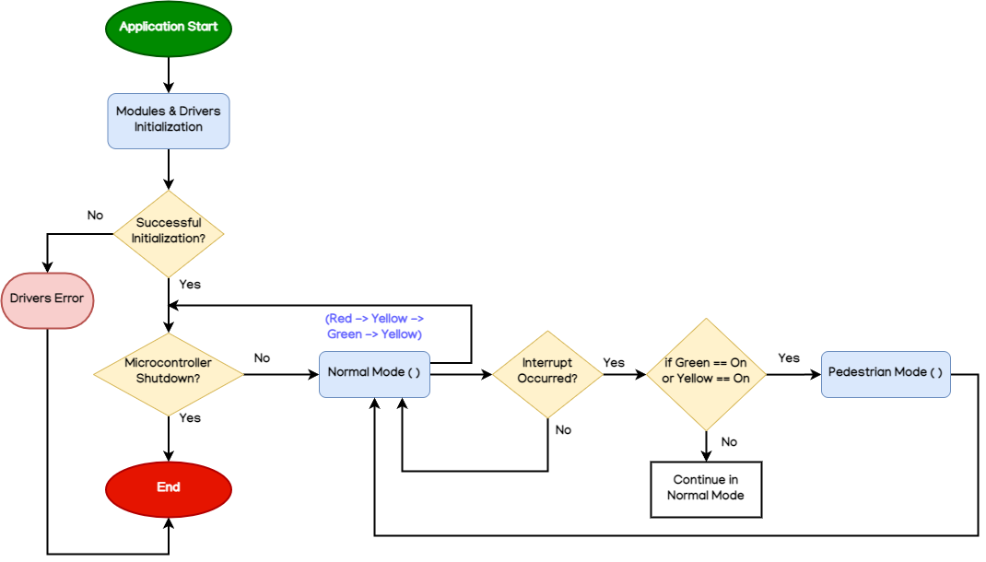All System Flowchart

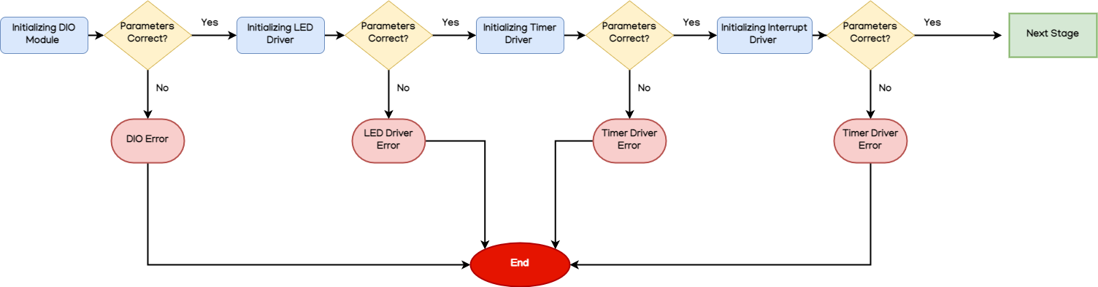- Modules & Drivers Initialization Flowchart

1. **System Constraints:**

* PORT A will contain LEDs for the Car Traffic Lights
* PORT B will contain LEDs for the Pedestrian Traffic Lights
* If the Interrupt button was pressed when Green or Yellow Car Traffic Lights was on, Pedestrian Mode is triggered.
* Long press is the same as a short press.
* Double press won’t do anything different then a normal press.